**School of Computer Science**

**UNIVERSITY OF PETROLEUM AND ENERGY STUDIES**

**DEHRADUN, UTTARAKHAND**



**Session – 2023-2024**

**TEST AUTOMATION**

**LAB FILE**

|  |  |  |  |  |  |  |
| --- | --- | --- | --- | --- | --- | --- |
| |  | | --- | | **Submitted By**- Mridul Singh | | **Sap ID**- 500094181 | | **Roll No**- R2142210501 | |  | | **Branch**- DevOps (H) B1 | | **Submitted To**- Dhiviya Rose  School of Computer Science |

**Index**

|  |  |  |
| --- | --- | --- |
| **S. no.** | **Experiment** | **Page No.** |
| 1 | Invoking the Webpage via WebDriver in Java Demonstration | 3-4 |
| 2 | Usability Testing | 5-8 |
| 3 | Usability Testing Report | 9-11 |
| 4 | **Creating Test Cases and Run it using TestNG Framework** | 12-14 |
| 5 | Mid Semester Assessment of Test NG | 15-17 |
| 6 | Create a Web Application for Stateless Login Checking | 18-19 |
| 7 | Traversing Through a Tutorial Website | 20-20 |
| 8 | Test Automating the Calculator Application | 21-22 |
| 9 | Working on XPath Selector | 23-24 |
| 10 | Project with Selenium & TestNG | 24-26 |

**Experiment – 1**

**Aim:** Invoking the Webpage via WebDriver in Java

**Downloading the selenium for java**

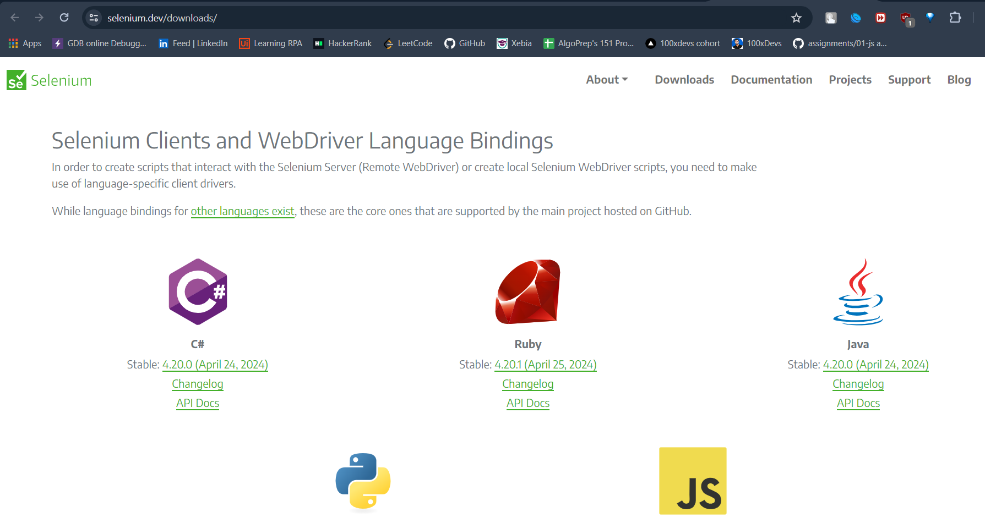

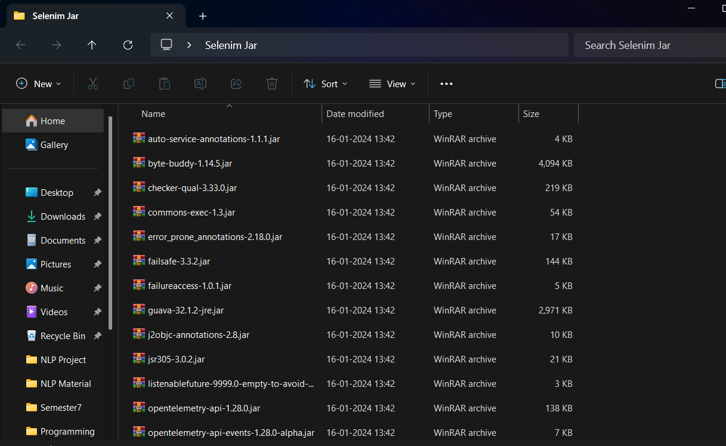

**Download chrome driver**

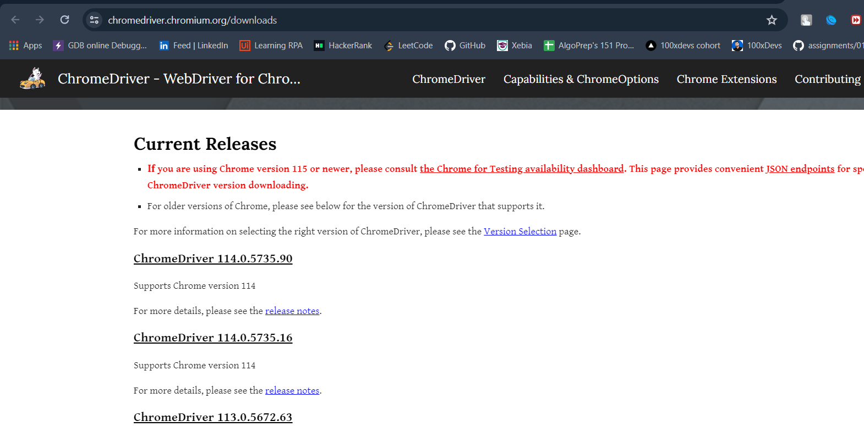

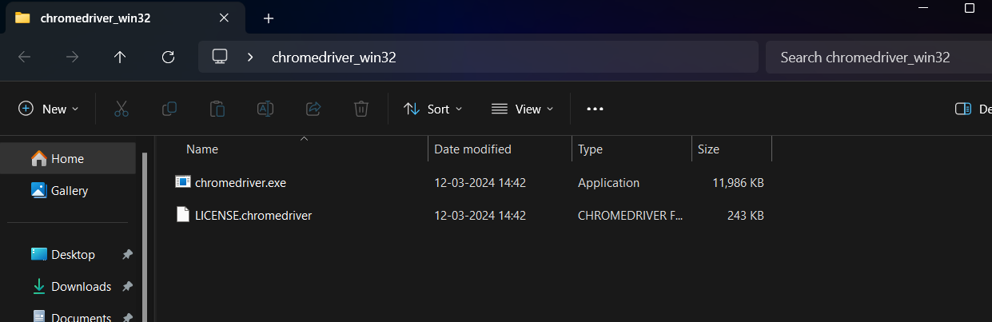

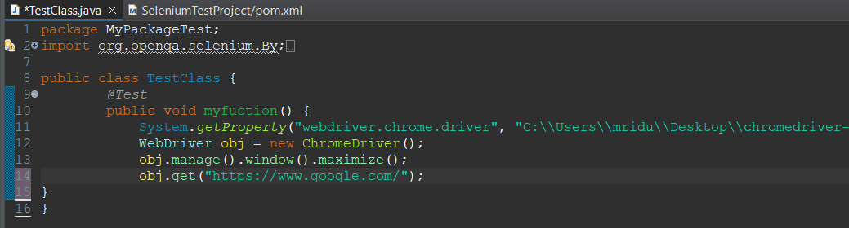

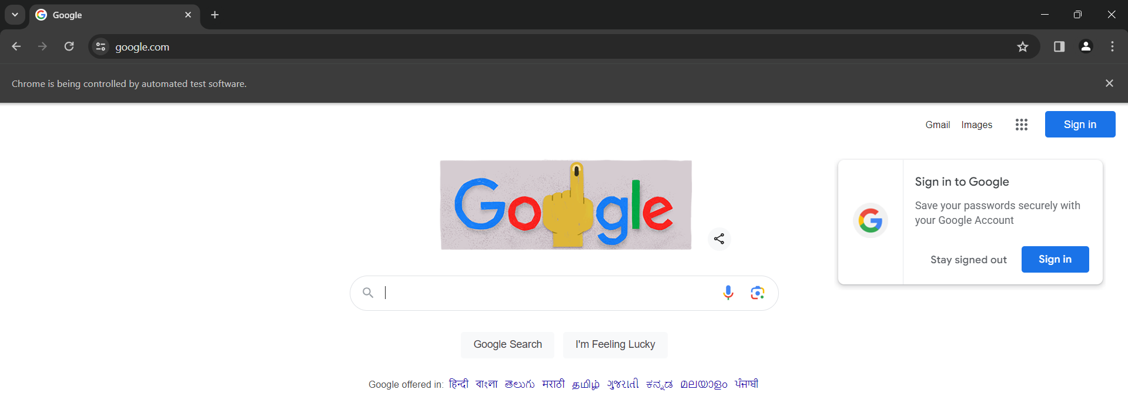

**Experiment - 2**

**Aim:** 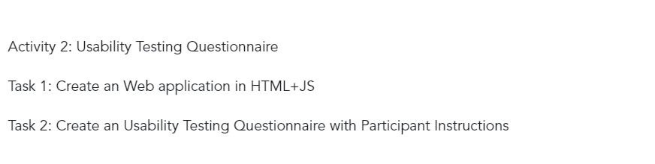

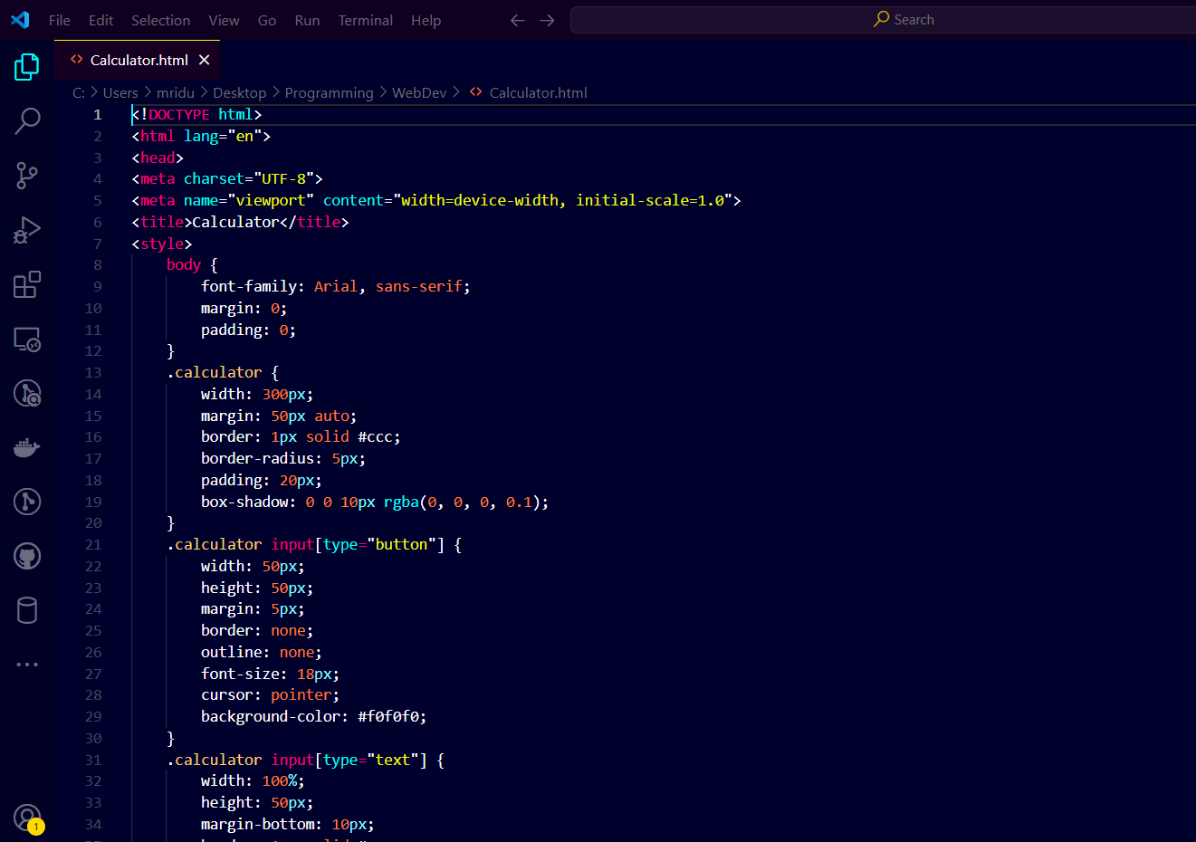

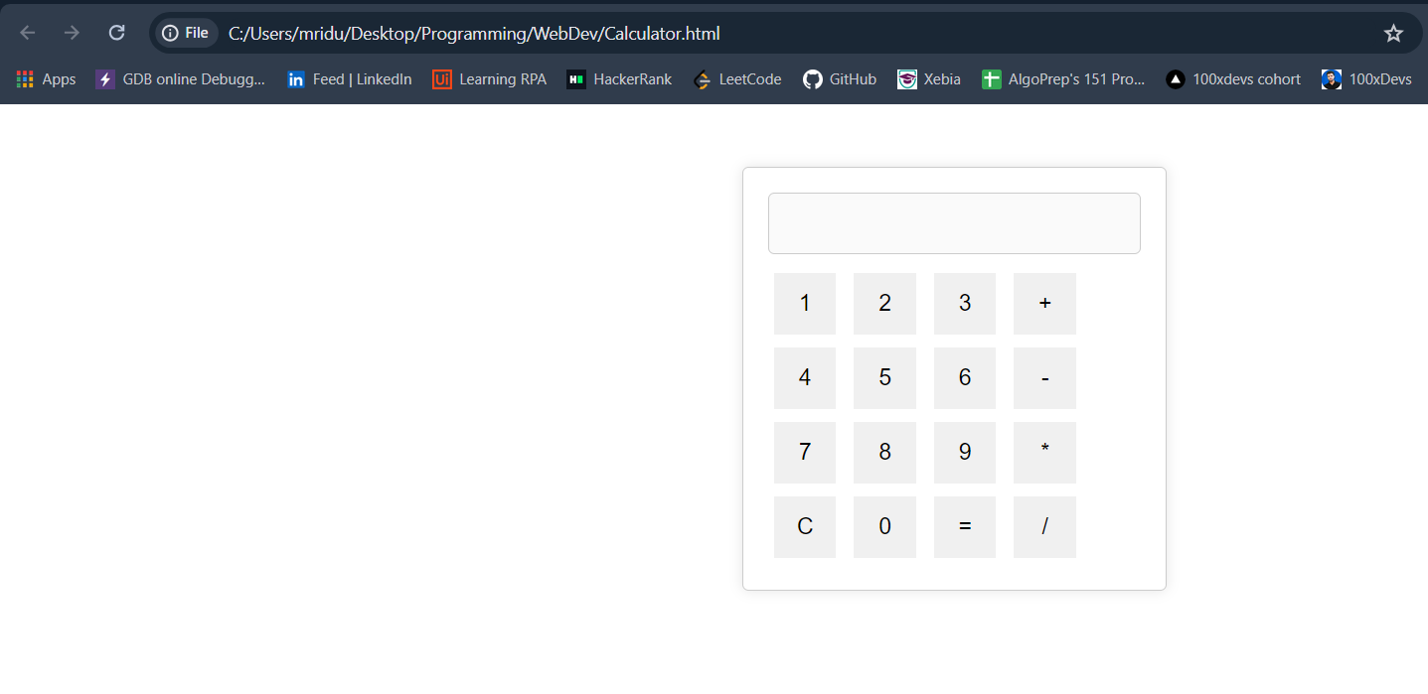

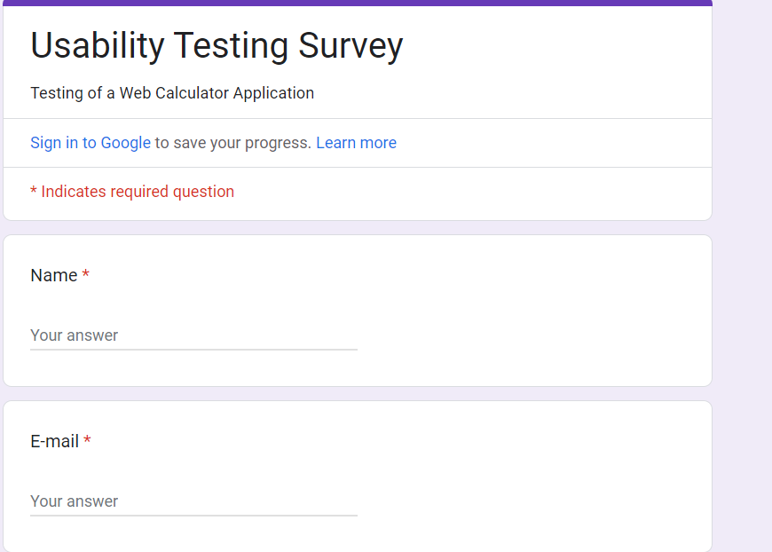 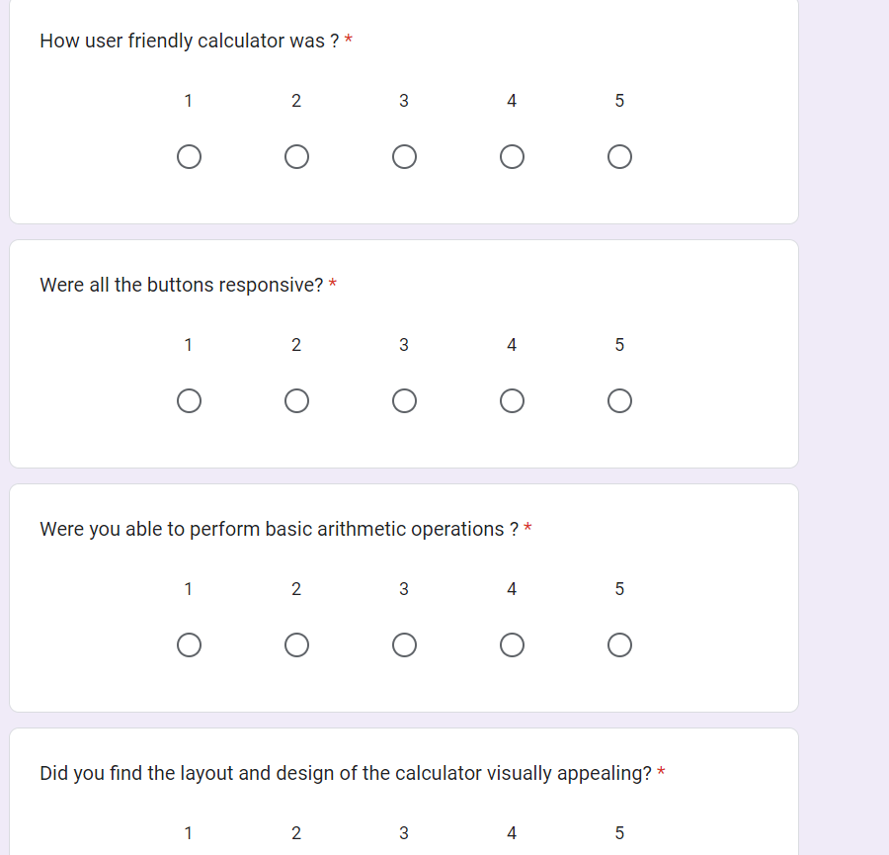

Forms response chart. Question title: How user friendly calculator was ?
. Number of responses: 4 responses. Forms response chart. Question title: How affected were you by the color palette used?
. Number of responses: 4 responses.

Forms response chart. Question title: How affected were you by the color palette used?
. Number of responses: 4 responses.

Forms response chart. Question title: Did you find the layout and design of the calculator visually appealing?
. Number of responses: 4 responses.Forms response chart. Question title: Were all the buttons responsive?
. Number of responses: 4 responses.

**Experiment – 3**

# Aim: Usability Test Report Submission

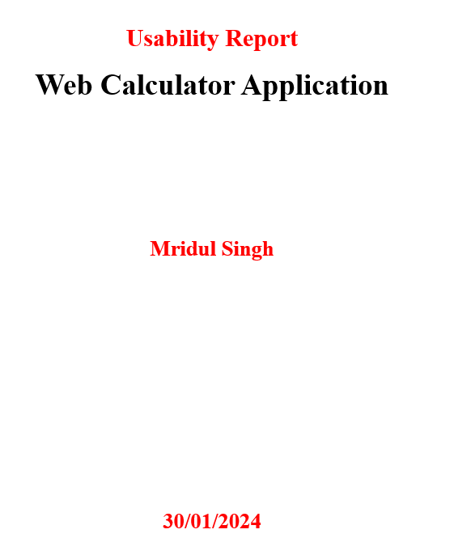

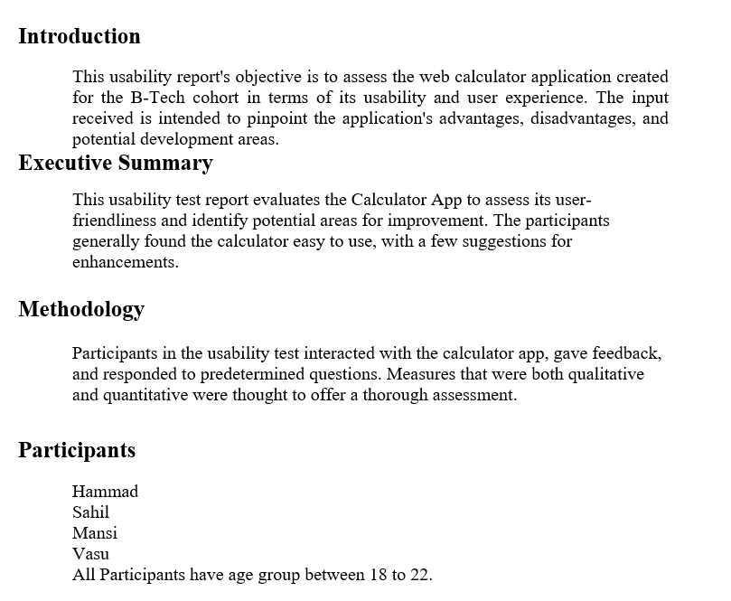

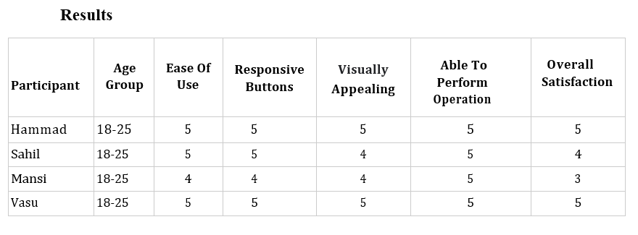

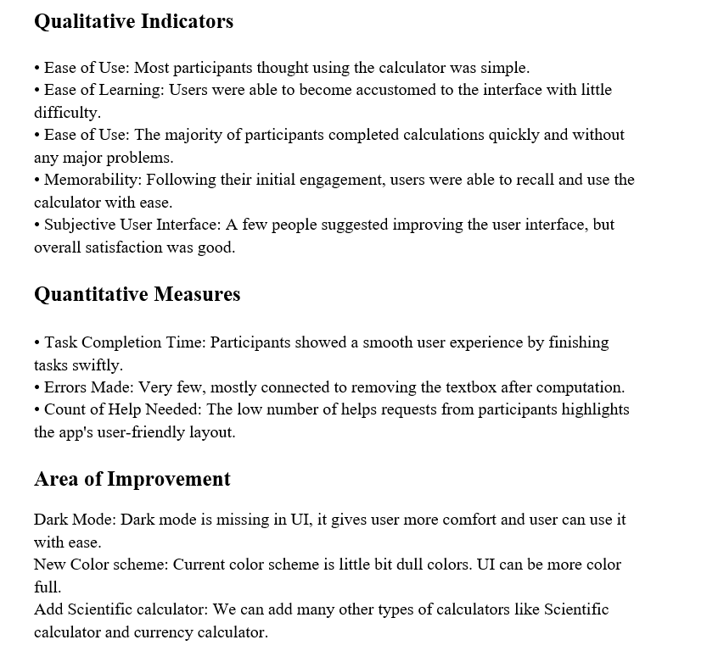

**Experiment – 4**

**Aim:**







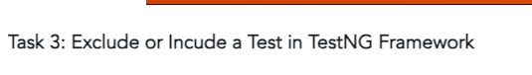

Create following classes inside the package:

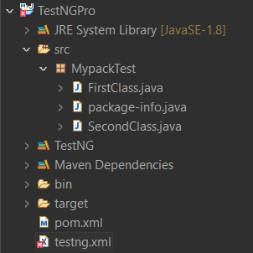

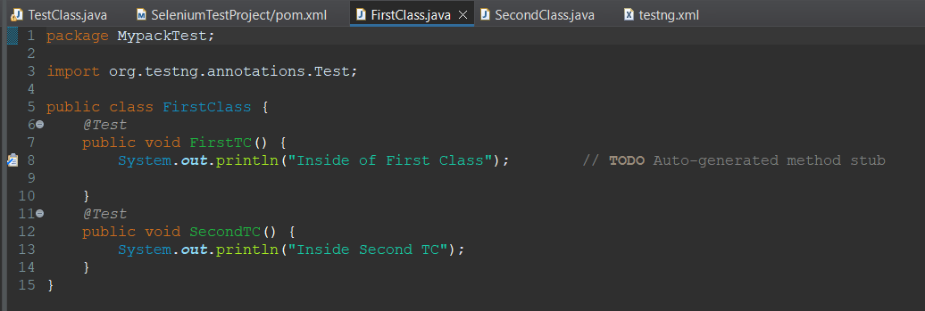

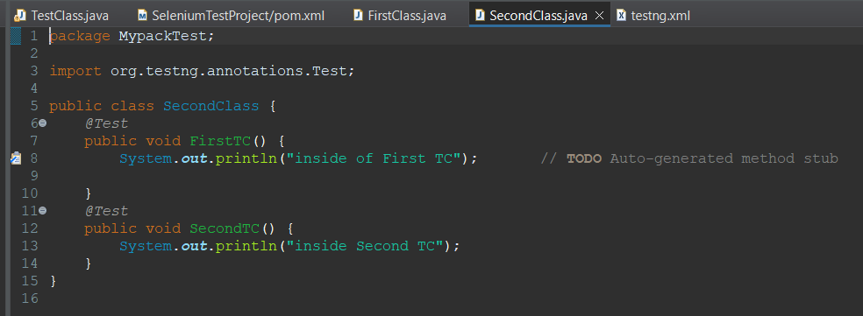

Add TestNG dependencies in pom.xml

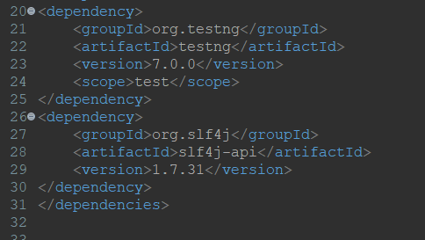

Create Testing.xml

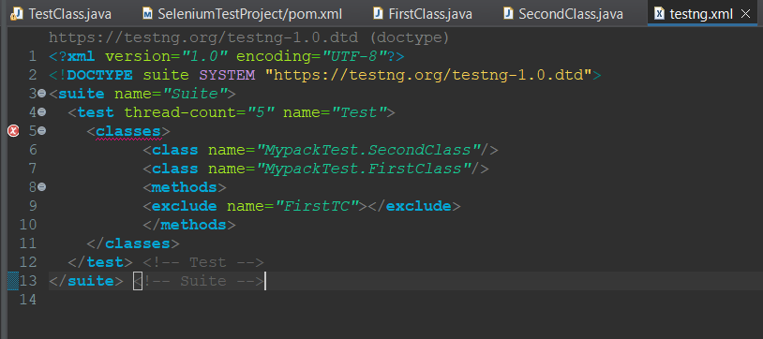

Run testing.xml

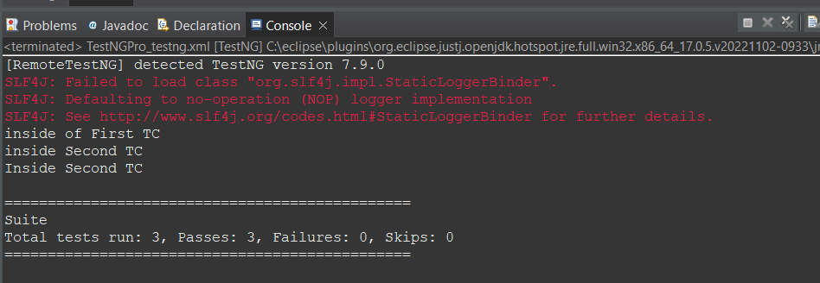

**Experiment – 5**

**Aim:** Mid Semester Assessment of Test NG

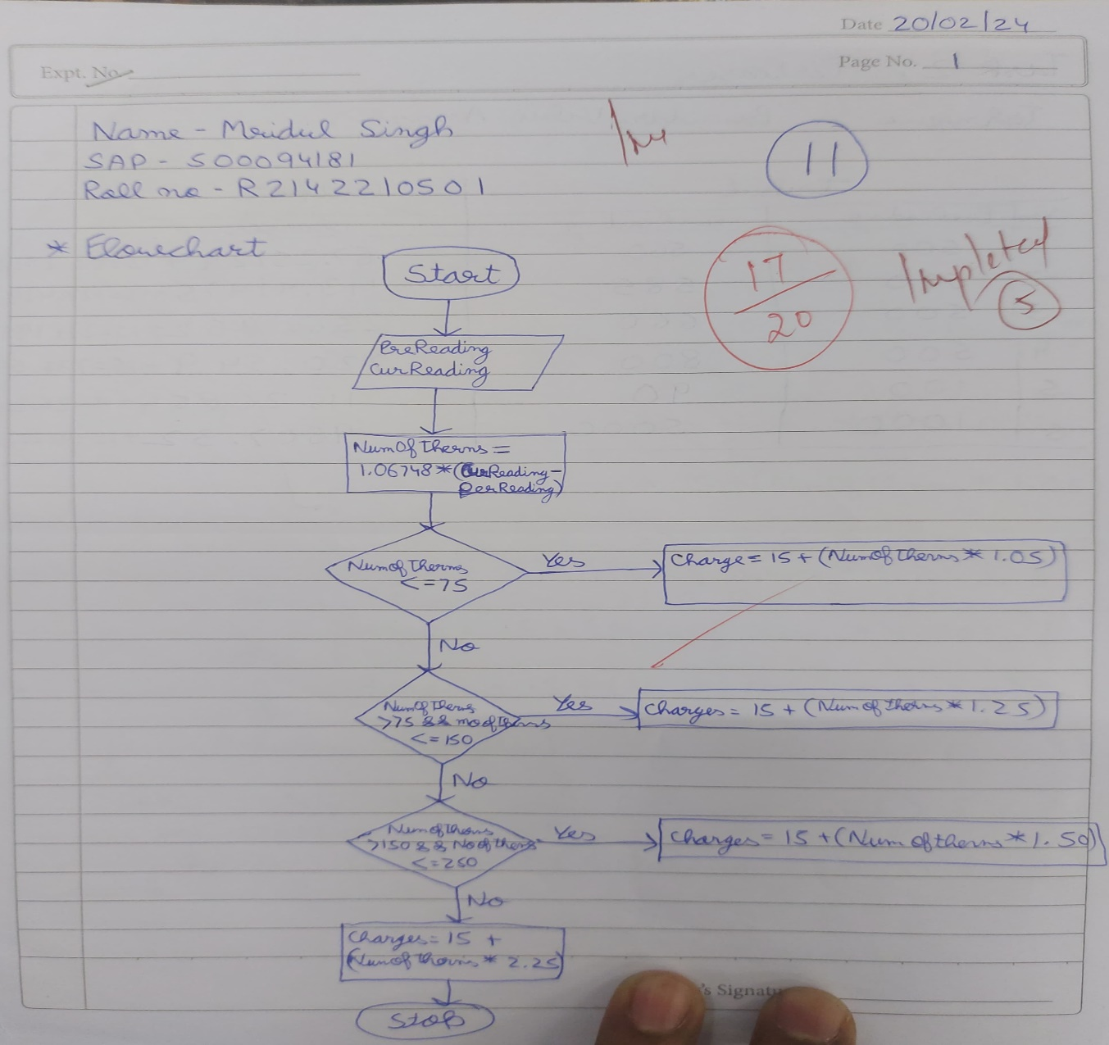

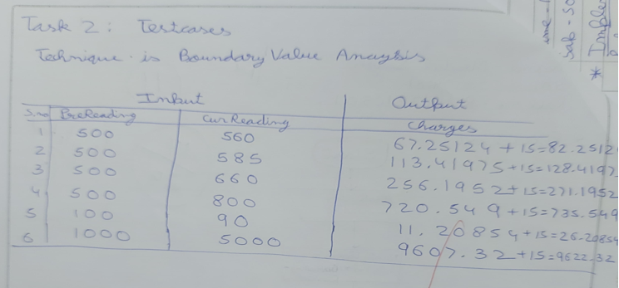

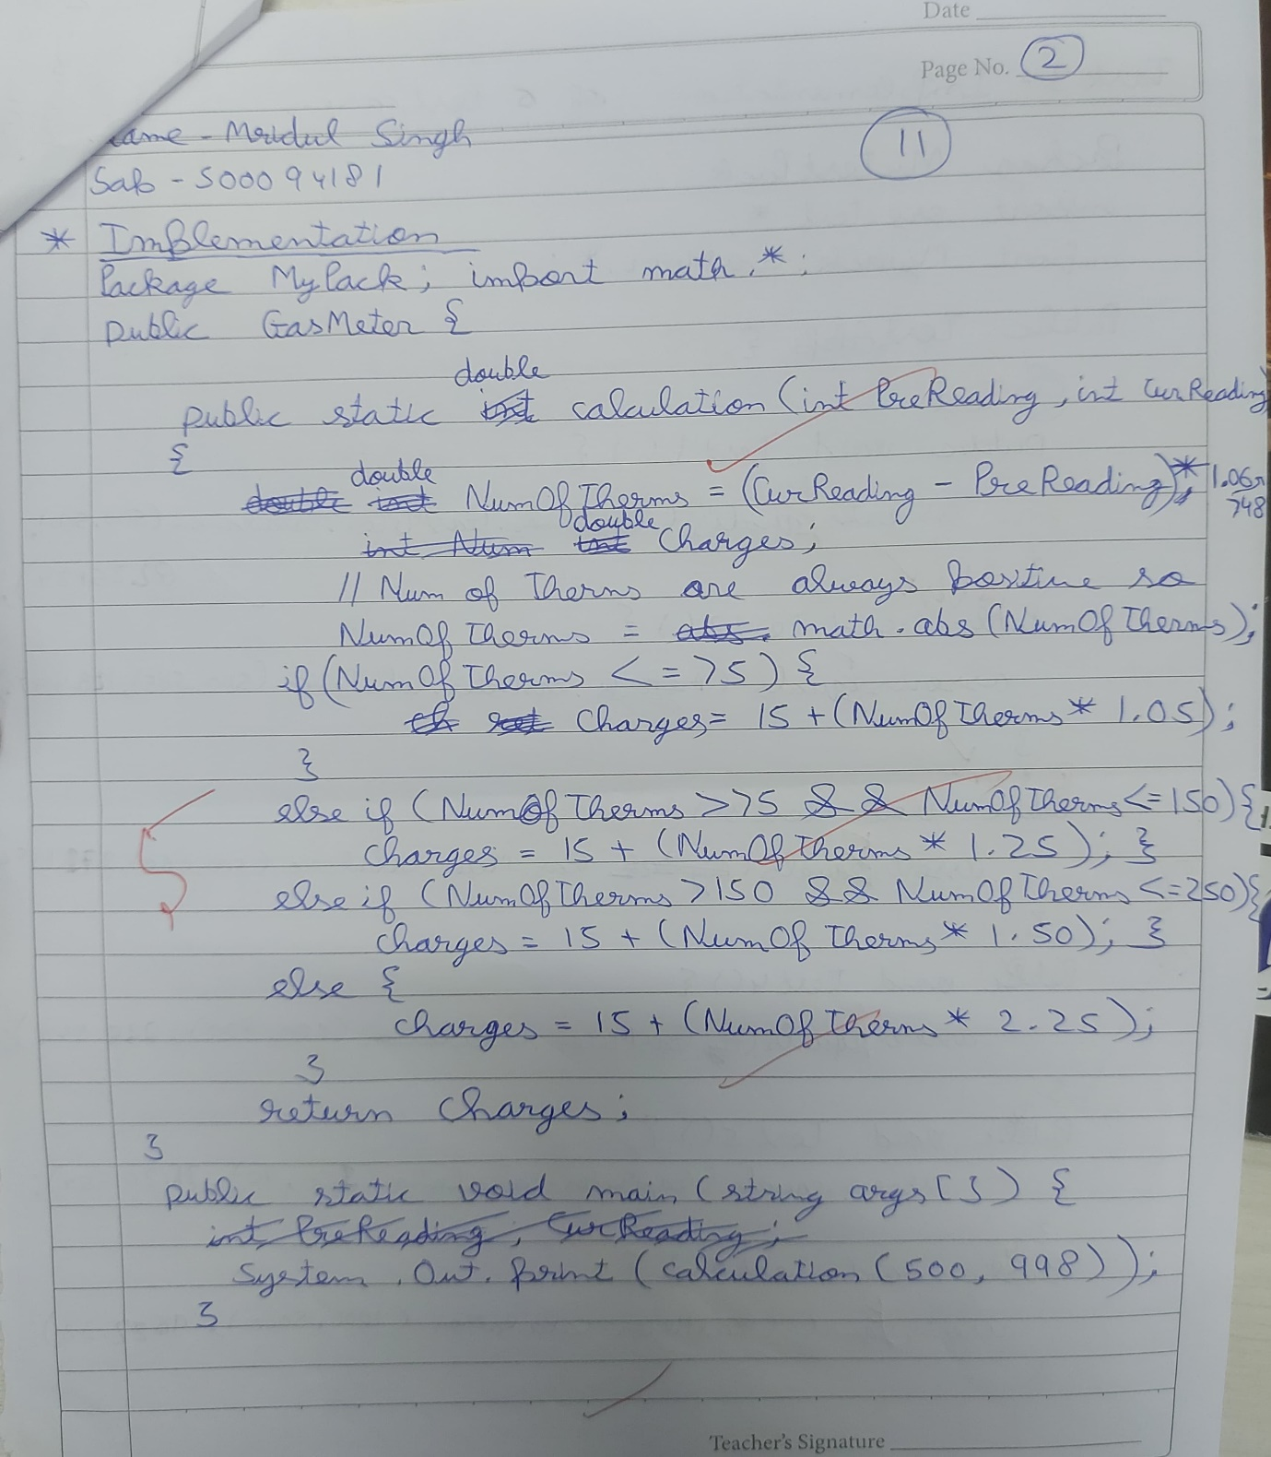

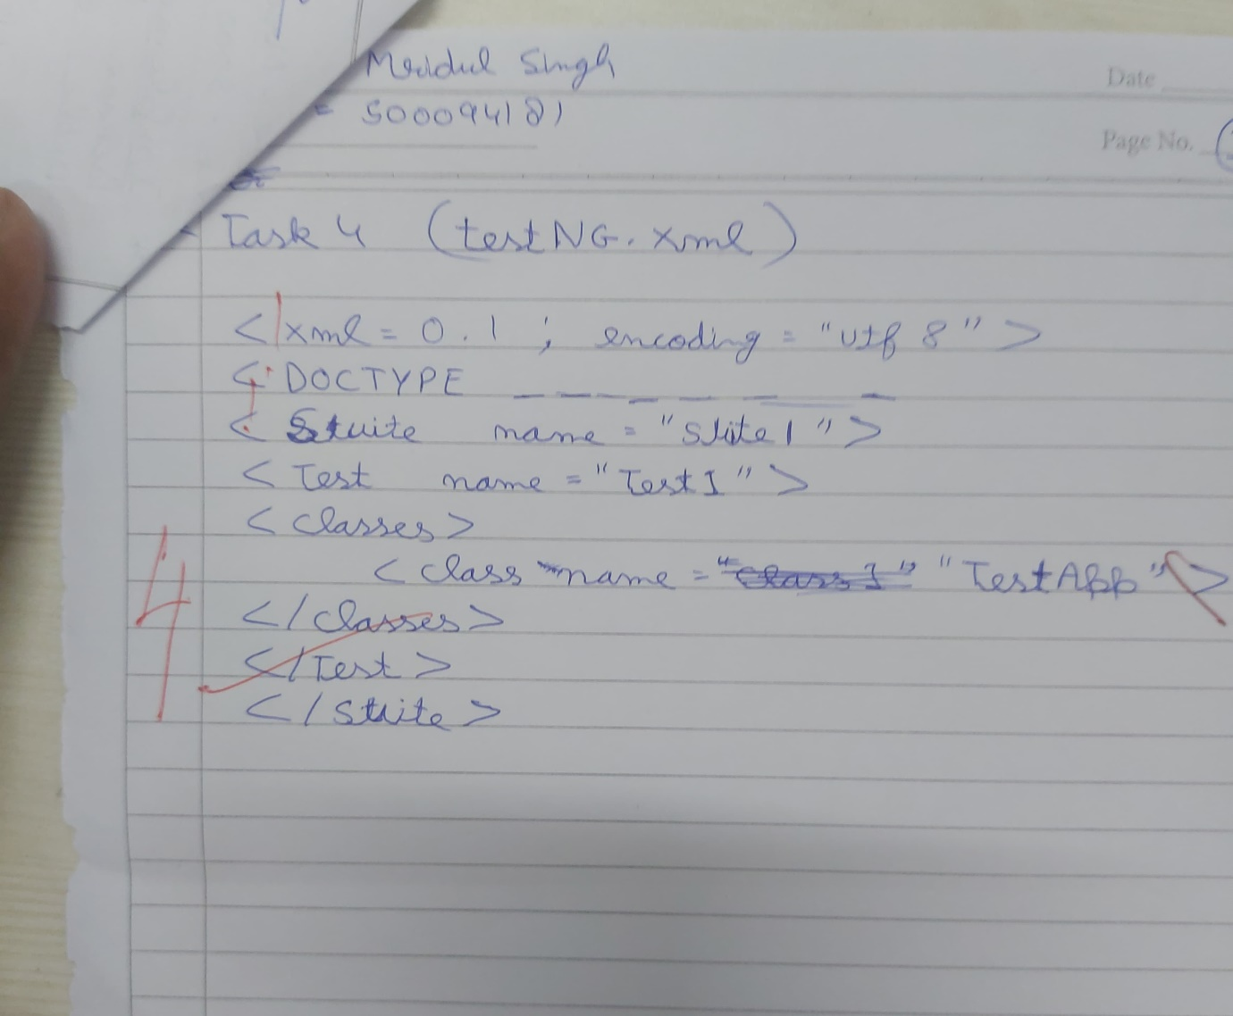

**Experiment – 6**

**Aim:** Create a Web Application for Stateless Login Checking.

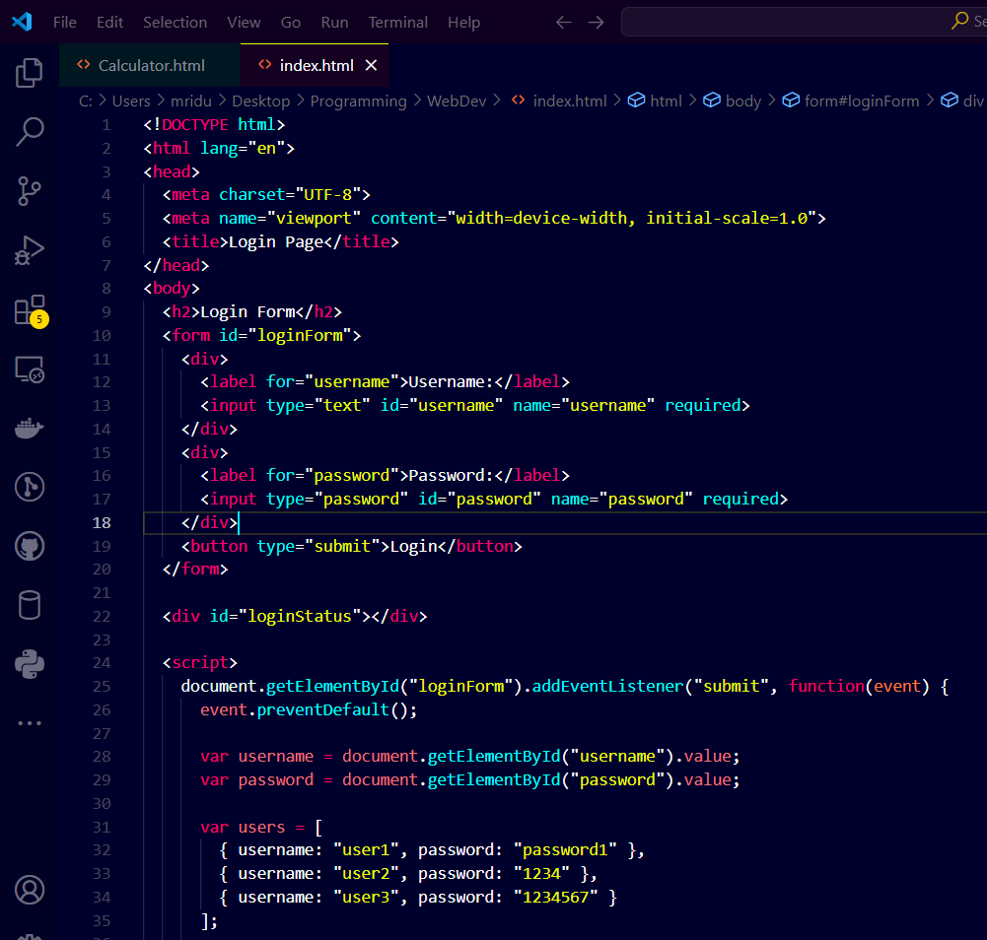

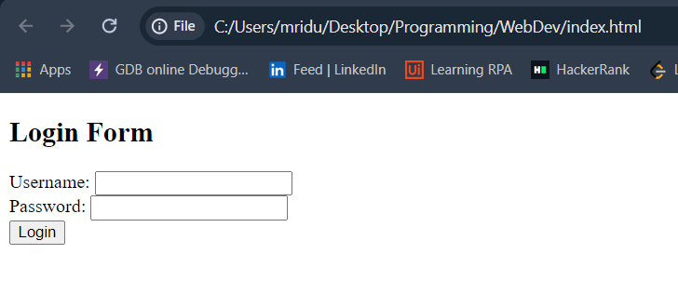

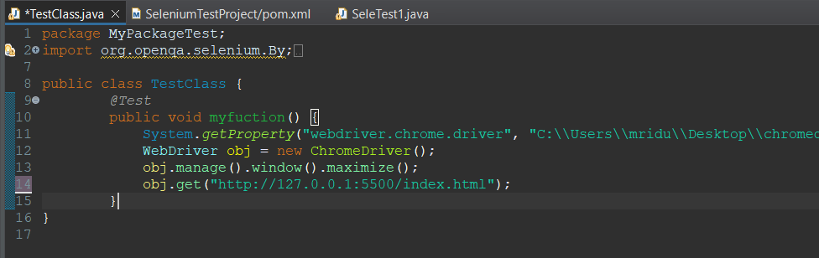

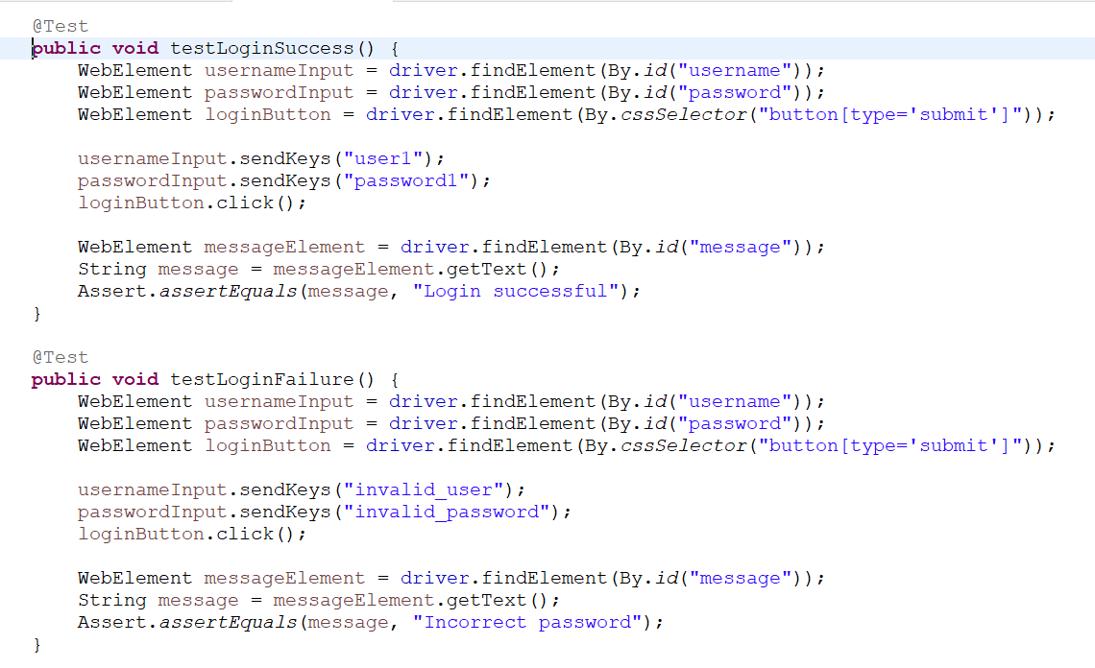

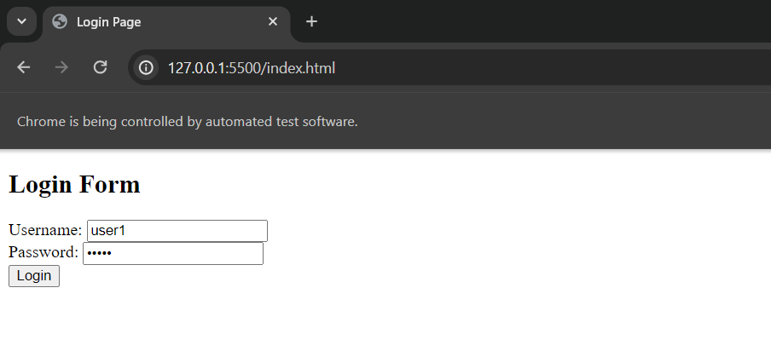

**Experiment – 7**

**Aim:**  Traversing Through a Tutorial Website

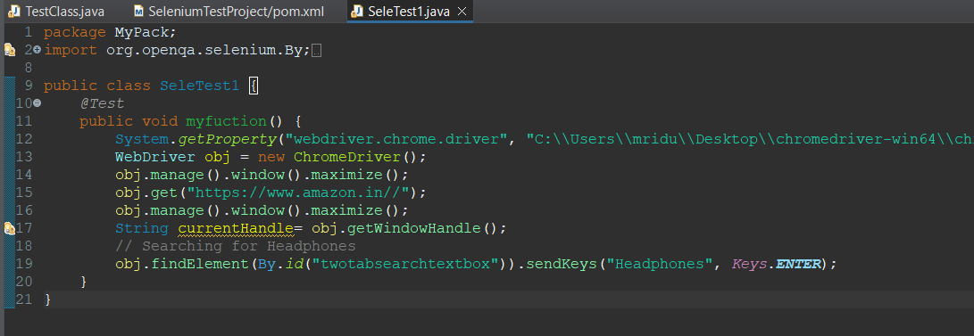

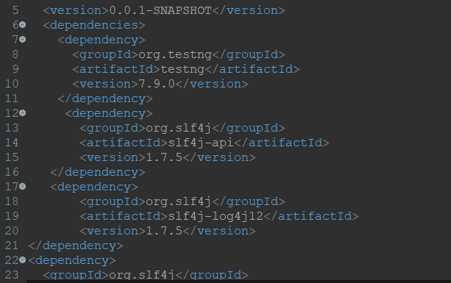

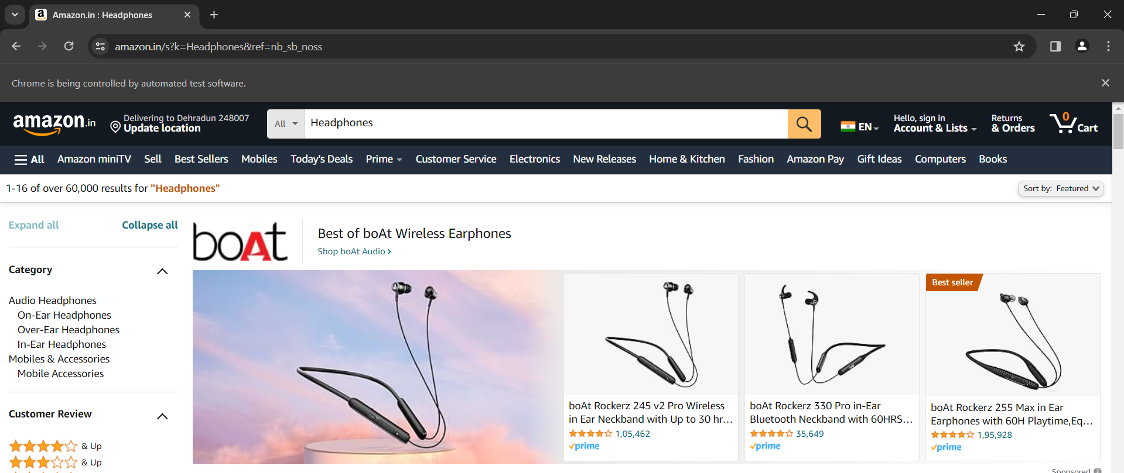

**Experiment – 8**

**Aim:** Test Automating the Calculator Application

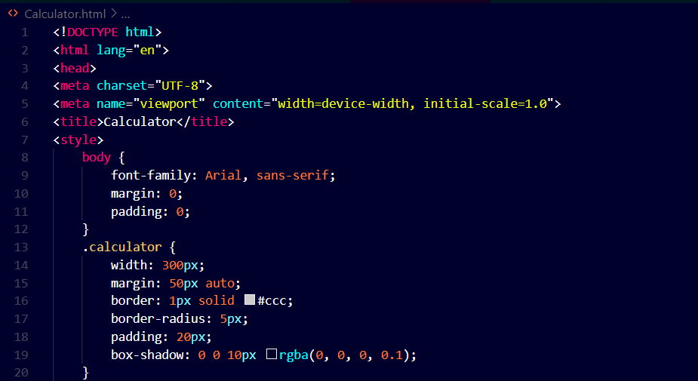

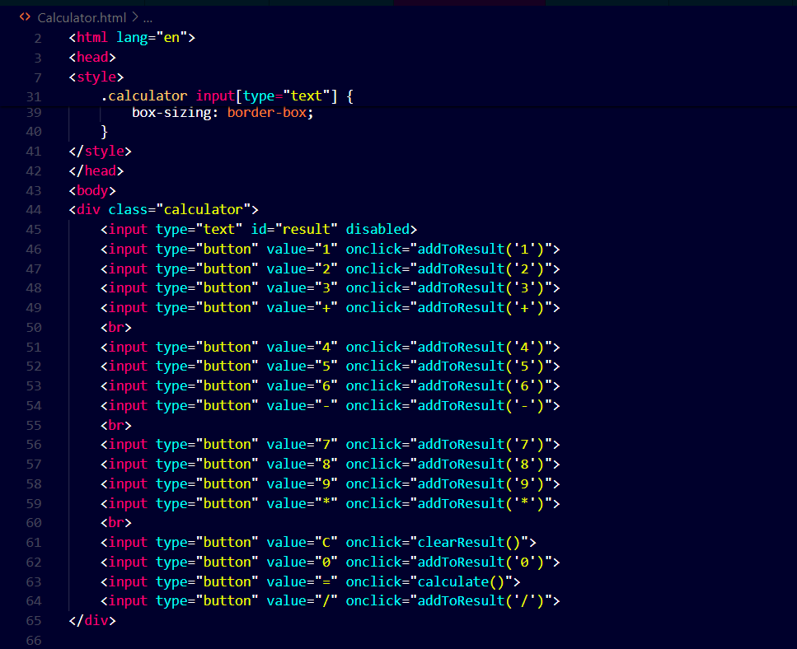

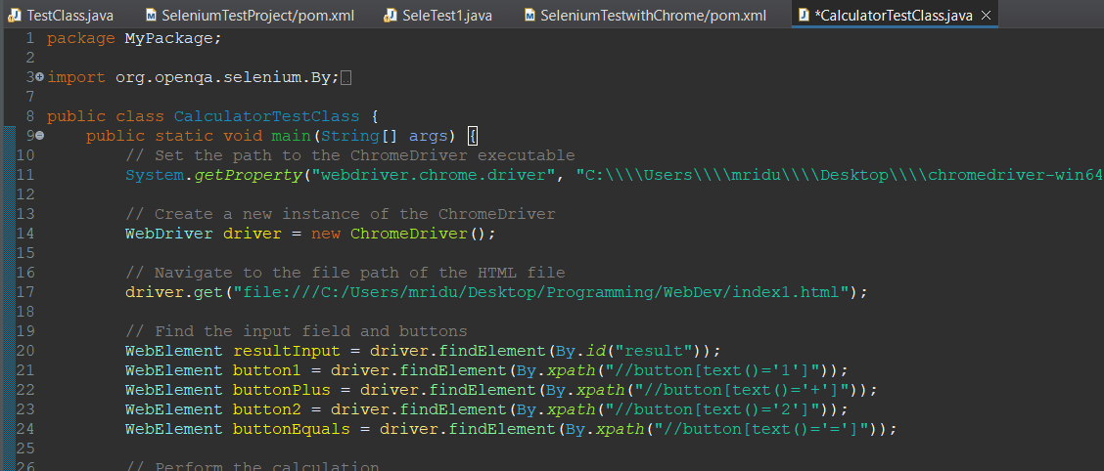

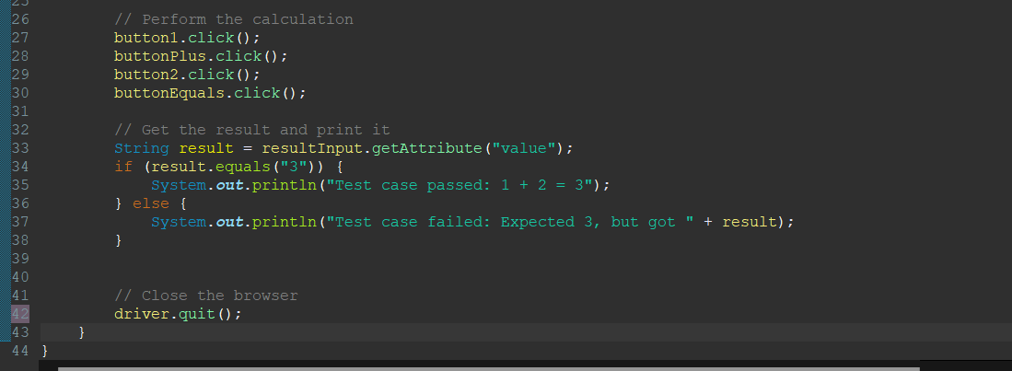

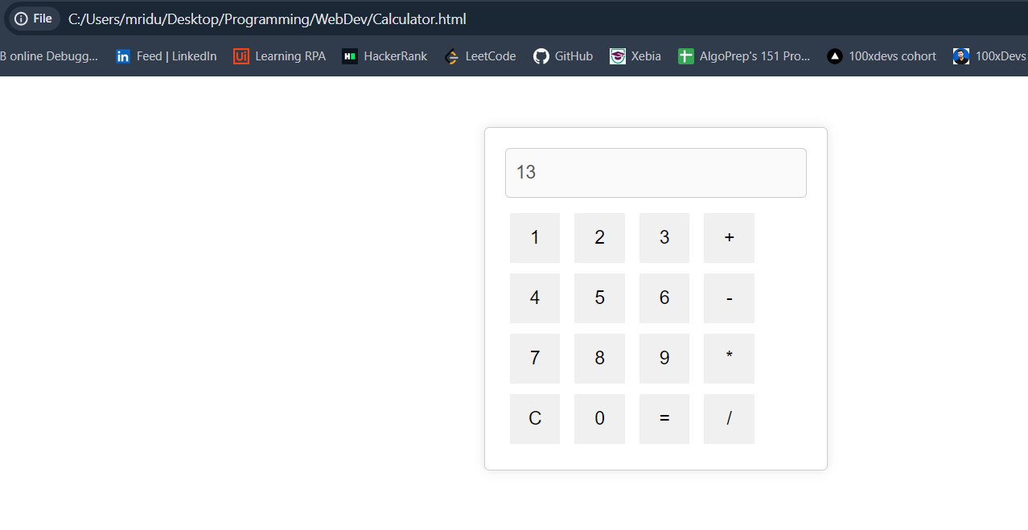

**Experiment – 9**

**Aim:**

Working on XPath Selector

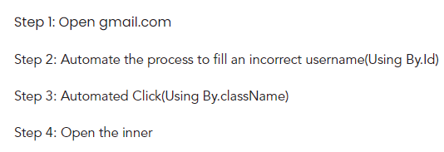

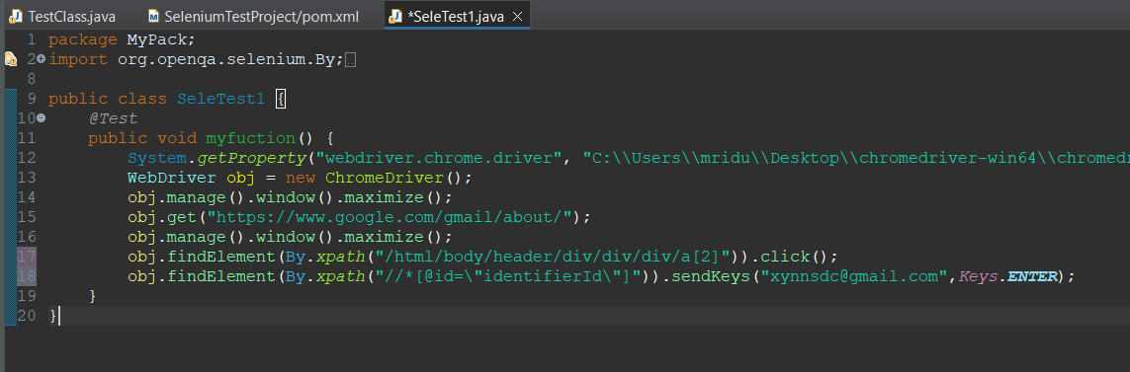



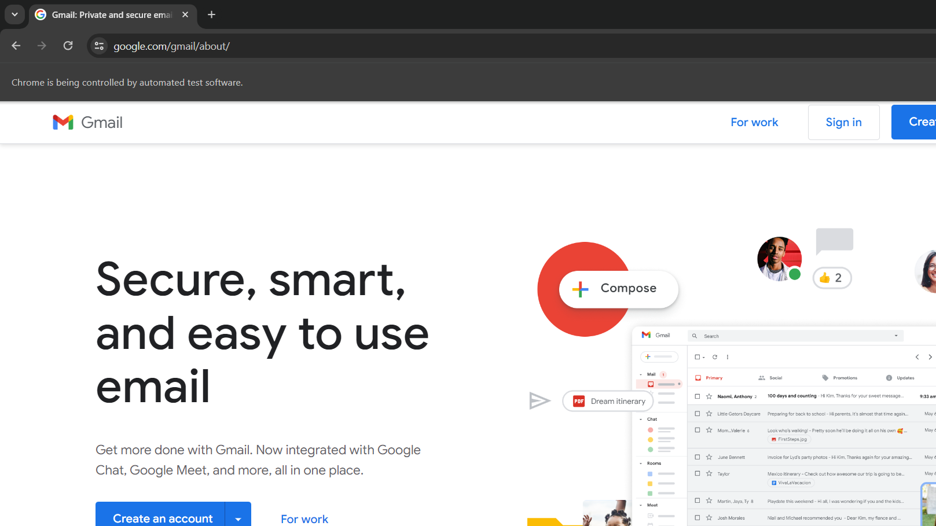

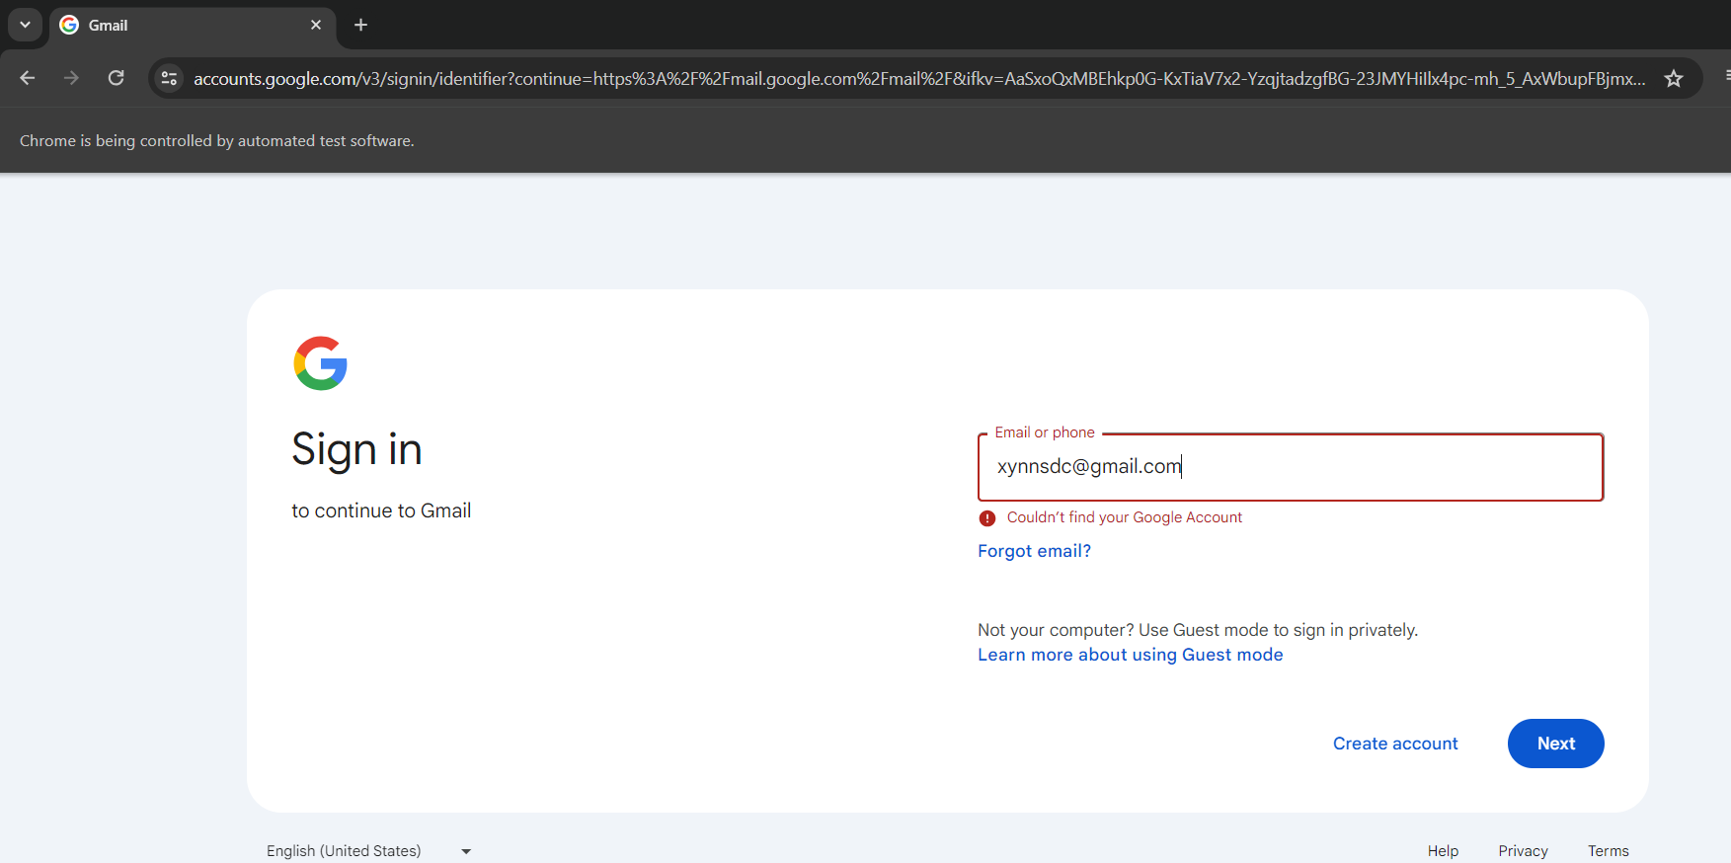

**Experiment – 10**

**Aim:** Project with Selenium & TestNG

Creating a Library management System And testing it using selenium.

